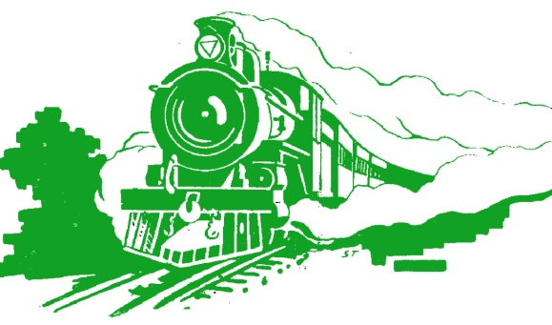
The Railway Museum
Western Australia

Excursion Management Plan
– primary school visits

The Railway Museum  136 Railway Parade  Bassendean  Western Australia 6054  Email: bookings@railheritagewa.org.au | Postal address:  P O Box 363  Bassendean WA 6934  Telephone (08) 9279 7189

Operated by
Rail Heritage WA

This museum is open to the public every Sunday 1-5 pm and Wednesday 1-4 pm. We also welcome school and other group visits on Wednesday mornings, or at other times by arrangement.

Ticket prices:

Normal ticket prices apply to school visits on Wednesdays, as at July 2013 these are:
Booking fee (includes 3 adults and information sent out) $30
Accompanying adults (after 1st 3) $9*
Children $4

* if accompanying persons are seniors or concession holders, $7

Visits are welcome on other days but we may need to charge a small extra fee for bringing suitable personnel in specially – please contact us for information.
____________________________________________________________________________________

Purpose of the Excursion

The purpose of visits to the Railway Museum is to better understand the importance of rail transport, both past and present, in Western Australia' history and development.

We cater for the Australian National Curriculum – professionally-prepared materials have recently been completed to assist teachers with using the new Curriculum, and these materials are available free to teachers and students beforehand so that the visit to the Railway Museum will be a valuable complementary experience.
The
Railway Museum is a valuable resource which chronicles the vital transportation networks that evolved since settlement; the building blocks that helped forge this state as the nation's most valuable resource rich state in Australia.

___________________________________________________________________________________

What we provide

- We can send you more information when you book your visit.
- We start visits with a rail safety video.
- Our comprehensive website and specially-prepared materials are available at all times.
- Guided tours, can be provided by our volunteers. We will do our best to tailor these to your purposes, but please remember our volunteers are knowledgeable about railways but are not experienced teachers!
_______________________________________________________________________________

Site and environment

The Railway Museum is located in Railway Parade, Bassendean. The grounds have a grassed area with roof for shade. In inclement weather, the large main roof area provides shelter whilst a carriage is available for children in groups to be spoken to or to eat sheltered from the rain.

Toilets are located to the rear of the museum site (men's, women's, and disabled) and there is tap drinking water available on site.

Since other parties may be using the museum at the same time, belongings should be left on your bus or may be left together in a section of the station (entry) building.

Transport to and from Railway Museum

Transport is the choice of the visiting school, but there are two main options:

Train: Dependant on school location, travel to the Railway Museum by Transperth train can be a valuable addition to the learning experience. From Ashfield station, walk over the footbridge to the north side (left side, looking away from Perth) which is Railway Parade, cross over Railway Parade to gain the footpath and walk approximately 400 metres east (away from Perth) to the Railway Museum.
This experience will be reinforced by a Transperth safety video which we show on group's arrival.

Bus: parking is available on Railway Parade opposite the museum entry (facing west, i.e. towards Perth). Alternately, to avoid students walking across Railway Parade, please call prior to arrival and we can open the gates to the driveway so that a bus can be parked inside.

Supervisor/supervisory team

The school supervisory team must accompany students throughout the excursion, actively monitor behaviour and intervene as necessary. Rail Heritage WA staff and volunteers can demonstrate and present activities but are not responsible for the supervision of students.

The maximum size for a school group should be kept to 30 students. Rail Heritage WA requests a minimum of 2 supervisors per visit group with a ratio of a minimum of 1 adult to 10 students for Years 2 -7.
All supervisors attending with the children should have current Working with Children clearances.
_____________________________________________________________________________

External Provider Information

Clearances
The primary responsibility for safety and behaviour of school children rests with supervisors from the school.
However, the Railway Museum does roster at least one employee or volunteer with a Working with Children clearance among those welcoming any school group – this will normally be the person providing guided tours (when requested by teacher).

Public Liability Insurance
Rail Heritage WA is the trading name of the Australian Railway Historical Society WA Division Inc (ARHS), a society incorporated under the Associations Incorporation Act (WA). The society maintains Public Liability insurance. A copy of our current renewal certificate is available on request.

ABN 64 295 981 165

Emergency Response Plan

The Railway Museum is an extensive site, and visitors may be together or dispersed at any given time depending on the type of visit chosen by teachers.

In the event of an emergency, it is essential that all visitors take directions from Railway Museum staff and volunteers. If evacuation is essential all visitors should assemble at the car park.
Teachers would need to do a roll call and must notify Railway Museum personnel if any students are missing.
It is the responsibility of the school to provide basic first aid to any student if required. Our staff and volunteers will assist if possible. A basic first aid kit is kept in the station building.
_____________________________________________________________________________________

Briefing Students and Supervisors

School groups will be met by a Railway Museum staff member or volunteer who will welcome and brief students on arrival outlining the program of the visit and emergency information.

Pre-visit information

Materials will be found on our website at
http://www.railheritagewa.org.au/education
including
- This Excursion Management Plan, from which teachers are welcome to extract material for their own compliance documentation
- Materials for students studying the Australian Curriculum in upper primary (e.g. years 5/6), via link from above webpage
- Materials for younger students (e.g. years 2/3) are now available and can be provided direct on request – currently being formatted to add to website.

_______________________________________________________________________________________

About Rail Heritage WA

Rail Heritage WA has been working to preserve Western Australia’s rail transport heritage for fifty years, and building this museum for 40 years.
Rail Heritage WA is a non-profit society publishing journals and books, advising governments, and coordinating volunteers and members to preserve and make available our rail heritage. Our members and volunteers have established, maintained and operated this museum.

Our mission is
To provide access to, and promote understanding of, the history of railways in Western Australia

Other relevant details

If you require any further information or would like to discuss program details, please contact bookings@railheritagewa.org.au of telephone (08) 9279 7189 (only attended part-time; at other times please leave a message so we can call you back).
________________________________________________________________________________________

